Farmer Decision Tool for Soil Health and Productivity

**Learning Outcomes** At the end of this course, participants should be able to:

1. Understand what is soil health
2. Identify soils which are healthy and soils which are not healthy
3. Know the benefits of having healthy soils
4. Identify various ways to improve soil health
5. Create an action plan for improving soil health and productivity

**Pre-Requisites:** In order to benefit fully from this class, participants should have already attended the following classes:

1. No pre-requisite is needed

**Timing of this Lesson:** This lesson can take place late in the growing season so the participants can still compare crop growth and prepare for crop residue management, or it can take place 2-3 months before the beginning of the rainy season as they are developing their coming cropping plans.

**References:**

[Soil Health Assessment](https://www.nrcs.usda.gov/conservation-basics/natural-resource-concerns/soils/soil-health/soil-health-assessment). Natural Resources Conseration Service. United States Department of Agriculture

**Materials Needed:**

1. A field with good soil health nearby a field with poor soil health
2. 1 hoe or shovel
3. 2 containers to collect soil
4. Soil health poster
5. Flip chart and marker pens
6. Seeds (at least 10 per participant)

**Preparation:**

1. Sample the 2 soils ahead of time to assure that there are visible differences between them
2. Use the Decision Support Tool App to identify several high-potential sustainable intensification technologies suitable for this specific area.
3. Review all discussion questions and be prepared to guide the discussion appropriately.

# Learning Activities (Total time required = 2-3 hours)

# Introduction

## Opening Discussion – write their responses on the flip chart (15 minutes)

### Ask the group to explain how they know when a soil is healthy or fertile. What are the signs that they look for? (*Alternative question*: If you are looking for a piece of land for farming, what characteristics can tell you that a certain piece of land is good for farming?)

### Present the soil health poster and ask them which of the maize leaves looks like it was growing in a healthy soil.

### Ask if they have a word in their local language that is used to describe a healthy soil?

### Why is it important for our soils to be healthy? ***Allow them to give their answers first, but be sure that they discuss higher productivity, lower input costs, easier soil preparation, and greater drought tolerance.***

# Practical Training (60 minutes)

## Take the group to a field where regenerative agriculture has been practiced (e.g. Conservation Agriculture, double-up legumes, cover crops, etc.)

### **Dig 4-5 liters of topsoil and place them in the bucket**

## Take the group to a field where extractive agriculture has been practiced (e.g. continuous maize, crop residue burning, etc.)

### **Dig 4-5 liters of topsoil and place them in the bucket**

## Allow each farmer to take a handful of each soil and examine them for several minutes (if the sun is hot, take the buckets to a shady spot before destributing samples and holding the following discussion:

### **What differences have you seen between these two soils?** ***Allow them to give their answers first, but be sure that they discuss the following:***

#### The soil from the regenerative field is darker (have them compare the 2 colors to the Munsell Soil Color Chart on the poster).

#### The soil from the regenerative field is softer and more crumbly

#### The soil from the regenerative field has more roots growing in it

### **Which field has healthier-looking crops?** *If the field has already been harvested ask them if they remember which field was more productive during the previous season.*

### **Which field would you rather farm in the next season? Why?**

# Follow-up Discussion (45 minutes) Return to a comfortable meeting place for this discussion

## Discussion Questions:

### In your community, which soils tend to be healthier: Soils nearby the homestead where people are living, or soils which are far away from the homestead? Why?

### What is the “food” which makes soils healthy? *Allow them to give their responses, but if they struggle, help them see that it is the organic inputs like crop residues, manure, cover crops, etc. which truly “feed” soils.*

### The regenerative agriculture approach that we saw in the field showed us one way to improve soil health. What are some other ways we can improve soil health?

## Action Planning

### Review all the methods they have listed for improving soil health which you have written on the flip chart

### Supplement their list by writing down and explaining any other high-potential methods which you have identified for this community

### Ask them which of these methods they think will be most effective and most practical on their farms?

### Use the 10-seed method (***see Appendix A***) to identify the top 2-3 methods which they will try in the coming season.

### Offer to return to help them learn how to implement their priority methods and prepare a schedule for follow-up training.

### Ask them if they have any unanswered questions.

### Thank them for their wisdom and insights throughout the lessons!

**Appendix A: Ten-Seeds Method**

This method is used to help non-literate groups set priorities in a participatory manner. It can be used to select different crop varieties, different activities for the group to undertake, or even group leadership.

1. List the different options for which people will be voting. This may be done using pictures on pieces of paper. Discuss thoroughly what each option is to be sure that people know what they are voting for.
2. Place the papers on a table, or on the floor where all can see them.
3. Give every participant 10 seeds (or stones, or any other small objects). If you want to separate the answers of different groups (e.g. men and women) give a different kind of seed to each group.
4. Explain that each individual will use their seeds to indicate which option they prefer. They may put all their seeds on one paper, to indicate that the highly prefer this option, or they may distribute their seeds between several options which they like.
5. Allow everyone to place their seeds on the paper indicating the options they prefer.
6. Count the seeds on each paper to determine the group priority
7. Ask Participants to discuss why they voted for the different options.
8. If, during the discussion, people’s opinions are changed by the arguments of other group members, a second vote may be taken to finalize the decision.

### **Appendix B: Crop Options Matrix Exercise** (adapted from the [PICSA Field Manual](https://research.reading.ac.uk/picsa/wp-content/uploads/sites/76/Manuals-Resources/PICSA-Manual-English.pdf))

1. 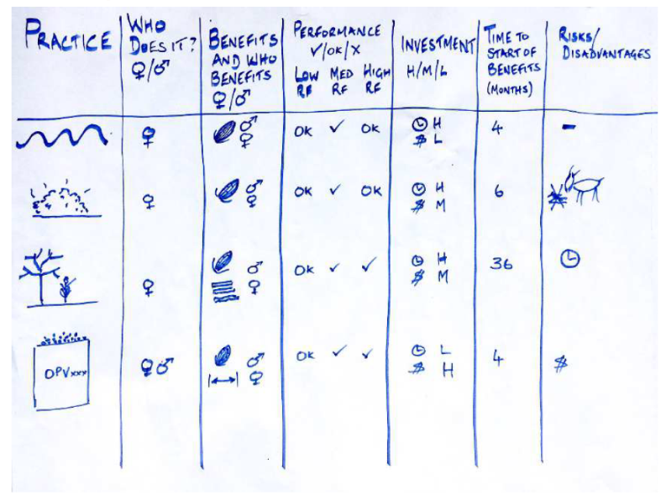Draw the outline of a SI Practices Matrix on a flipchart.
2. In the left column, list all the practices brainstormed by the farmers, as well as the practices identified by the SI for Soil Health app.
3. Explain each of the headings at the top of the matrix:
   1. Who does the practice: Ask farmers to identify whether the labour demand for the practice will be high moderate or low for women and also for men.
   2. Benefits and who benefits: Use this column to list how significantly each of the practices is likely to benefit them (e.g. food, cash income, fuel wood, etc.) Then ask farmers to indicate who is likely to benefit most from the practice - men, women or both.
   3. Performance in ‘Low’, ‘Medium’ and ‘High’ rainfall seasons / years: Use this column to consider how each of the crop practices will perform in rainfall scenarios.
   4. Investment: Use this column to consider the level of investment required for each practice. Is it high (H), moderate (M) or low (L).
   5. Time to benefit: Use this column to estimate how long it will take before they start to benefit from each practice. Make sure you take into account whether farmers would need extra time to learn new skills or acquire materials.
   6. Risks or disadvantages: Use this column to highlight any other risks involved with the practices (e.g. less crop residue for livestock feed if it is used for mulching).
4. Go through the crop practices one by one, asking the farmers about each of the headings and agreeing on what should be filled in. It is important that the decisions are made by the group and not by you, the facilitator.
5. Ask the farmers to identify which practices are likely to be helpful in most seasons (whether they are low, medium or high rainfall seasons) or that will still give a reasonable yield in poor seasons. Mark these with a circle.